AI POWERED IMAGE RECOGNITION USING AWS
Introduction
What is Image Recognition: -
AI technology that identifies objects, people, text, and patterns in images.
Project Goal:
To build a secure, scalable, serverless system to automatically analyse images uploaded to the cloud and store results for easy access.
Benefits:
- Fully automated, real-time image recognition pipeline.
- Serverless architecture means no infrastructure management.
- Scalable and cost-effective.
- Secure access with IAM roles and policies.
- Fast metadata retrieval and analysis.
Step-by-Step Implementation:
Step 1: Create a S3 Bucket
Step 2: Image Upload
Step 3: Lambda Trigger
Step 4: Image Processing
Step 5: Store Metadata
Step 6: Secure Access

Tools & Technologies Used for this project:
- Amazon S3 - Securely stores uploaded images
- AWS Lambda - Processes images when triggered by S3
- Amazon DynamoDB - Stores image metadata and recognition results
- AWS IAM - Controls permissions and service access

Implementation Approach:
Step 1: Create a S3 Bucket

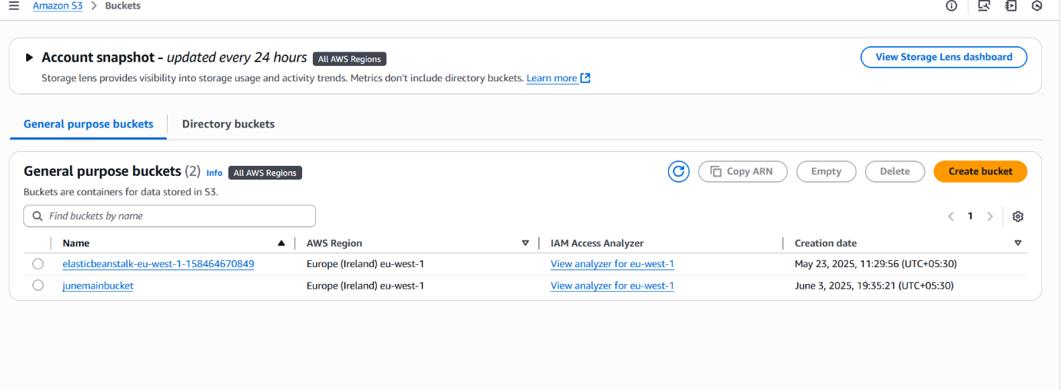

Step 2: Image Upload
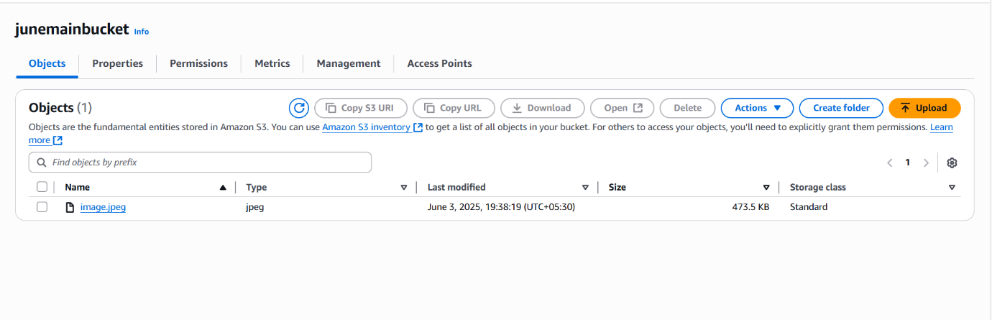

Step 3: Lambda Trigger
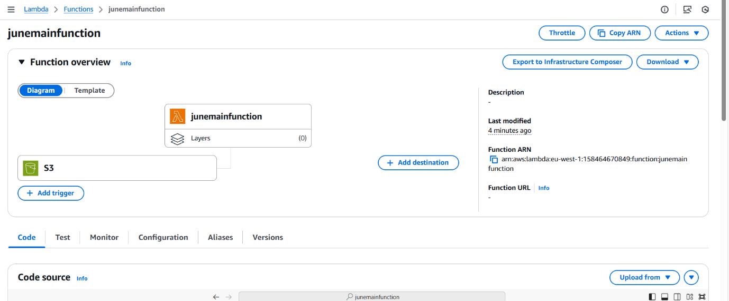

Step 4: Image Processing
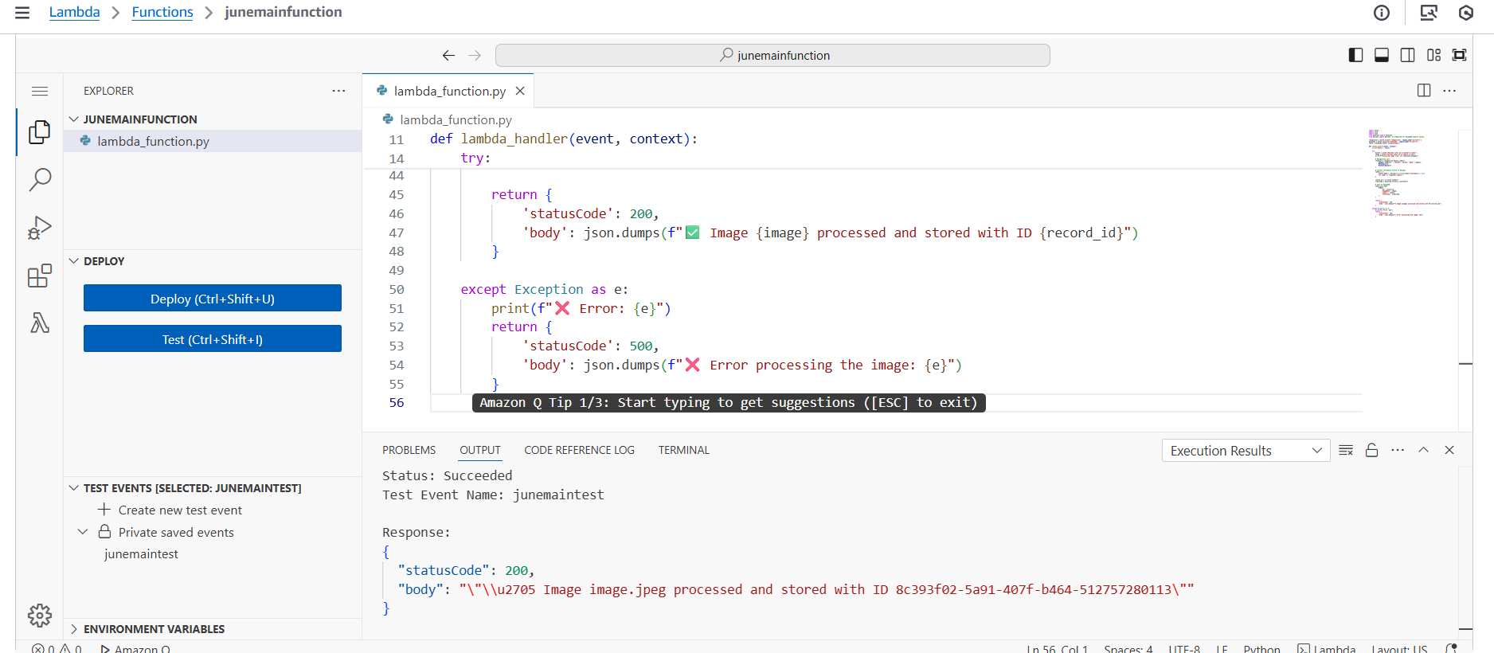

Step 5: create an DynamoDB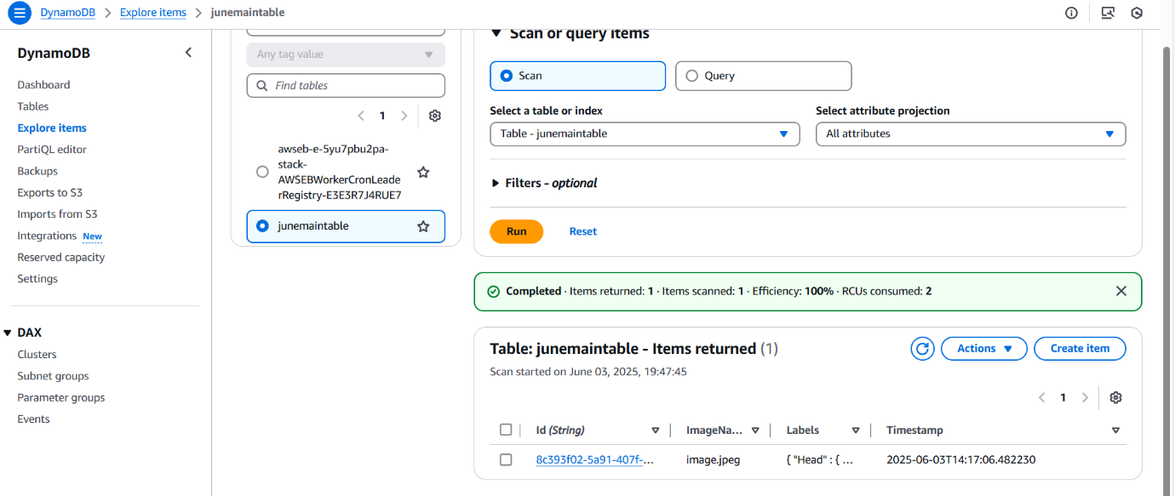

Step 5: Store Metadata
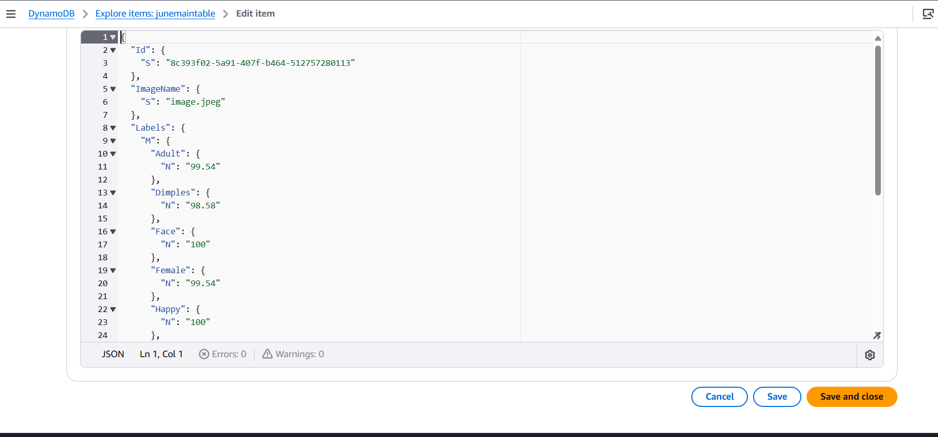

Step 6: Secure Access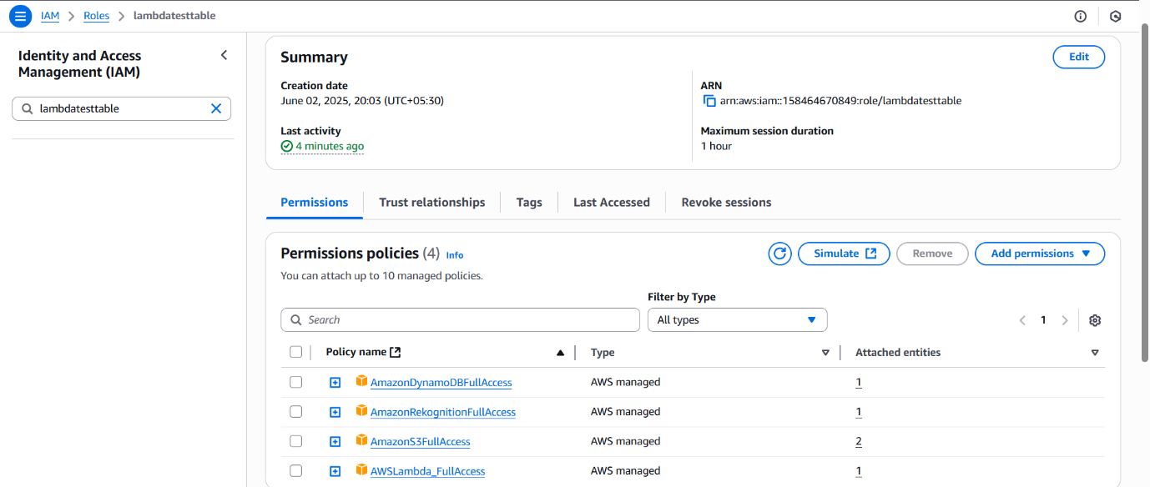

Conclusion:

So, we have achieved the following
- Developed a secure, scalable AI-powered image recognition system on AWS
Leveraged core AWS services (S3, Lambda, Rekognition, IAM, DynamoDB) to create a robust and secure pipeline.
- Automated image processing from upload to metadata storage
Fully event-driven, serverless workflow with minimal human intervention.
- Ready for enterprise-grade deployments with future scalability
Designed for high availability, cost-efficiency, and integration with enterprise systems.
- Integrated AWS Rekognition for intelligent image analysis
Enables automatic detection of objects, scenes, text, and more with high accuracy.
- Implemented fine-grained IAM policies for secure service communication
Ensures that only authorized components can access S3, Lambda, and DynamoDB.
- Structured metadata storage using DynamoDB for fast querying
Allows fast, scalable access to image insights for reporting, dashboards, or analytics tools.

